Cristiam Server
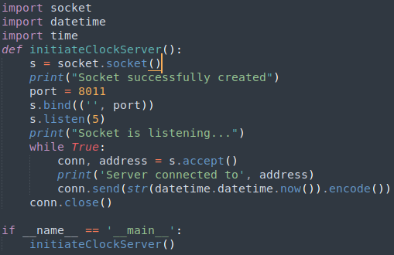
Cristian Client
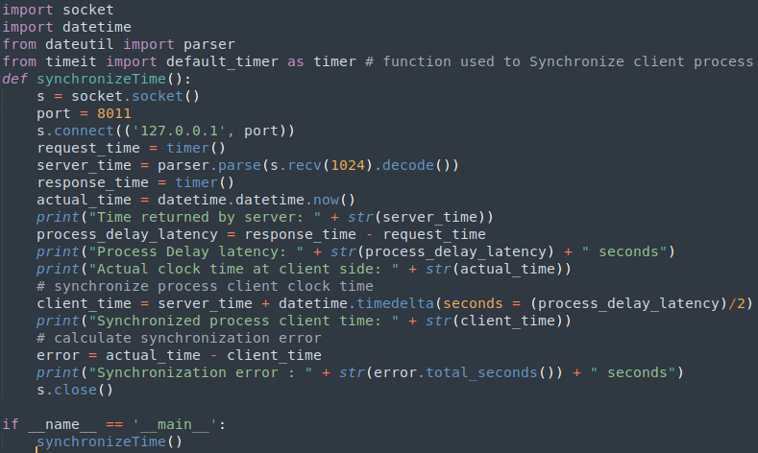
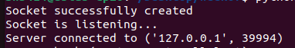

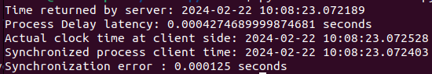

Berkeley Server

from functools import reduce
from dateutil import parser
import threading
import datetime
import socket
import time
client_data = {} #to store client address and clock data
def startRecieveingClockTime(conn, address): #nested thread function used to receive clock time from a connected client
while True:
clock_time_string = conn.recv(1024).decode()
clock_time = parser.parse(clock_time_string)
clock_time_diff = datetime.datetime.now() - clock_time
client_data[address] = {"clock_time": clock_time,"time_difference" : clock_time_diff,"connector": conn}
print("Client Data updated with: "+ str(address),end = "\n\n")
time.sleep(5)

def startConnecting(master_server): #master thread function used to open portal for accepting clients over given port
while True: # fetch clock time at slaves / clients
# accepting a client / slave clock client
master_slave_connector, addr = master_server.accept()
slave_address = str(addr[0]) + ":" + str(addr[1])
print(slave_address + " got connected successfully")
current_thread = threading.Thread(target = startRecieveingClockTime,args = (master_slave_connector,slave_address, ))
current_thread.start()

# subroutine function used to fetch average clock difference
def getAverageClockDiff():
current_client_data = client_data.copy()
time_difference_list = list(client['time_difference'] for client_addr, client in client_data.items())
sum_of_clock_difference = sum(time_difference_list, datetime.timedelta(0, 0))
average_clock_difference = sum_of_clock_difference / len(client_data)
return average_clock_difference

def synchronizeAllClocks():
while True:
print("New synchroniztion cycle started.")
print("Number of clients to be synchronized: " + str(len(client_data)))
if len(client_data) > 0:
average_clock_difference = getAverageClockDiff()
for client_addr, client in client_data.items():
try:
synchronized_time = datetime.datetime.now() + average_clock_difference
client['connector'].send(str(synchronized_time).encode())
except Exception as e:
print("Something went wrong while sending synchronized time through " + str(client_addr))
else :
print("No client data. Synchronization not applicable.")
print("\n\n")
time.sleep(5)

# function used to initiate the Clock Server / Master Node
def initiateClockServer(port = 8080):
master_server = socket.socket()
master_server.setsockopt(socket.SOL_SOCKET,socket.SO_REUSEADDR, 1)
print("Socket at master node created successfully\n")
master_server.bind(('', port))
master_server.listen(10)
print("Clock server started...\n")
print("Starting to make connections...\n")
master_thread = threading.Thread(target = startConnecting,args = (master_server, ))
master_thread.start()
# start synchroniztion
print("Starting synchronization parallely...\n")
sync_thread = threading.Thread(target = synchronizeAllClocks,args = ())
sync_thread.start()

if __name__ == '__main__':
initiateClockServer(port = 8080)

Berkeley Client

from timeit import default_timer as timer
from dateutil import parser
import threading
import datetime
import socket
import time
def startSendingTime(slave_client): # client thread function used to send time at client side
while True:
# provide server with clock time at the client
slave_client.send(str(datetime.datetime.now()).encode())
print("Recent time sent successfully",end = "\n\n")
time.sleep(5)

# client thread function used to receive synchronized time
def startReceivingTime(slave_client):
while True:
# receive data from the server
Synchronized_time = parser.parse(slave_client.recv(1024).decode())
print("Synchronized time at the client is: " + str(Synchronized_time),end = "\n\n")

# function used to Synchronize client process time
def initiateSlaveClient(port = 8080):
slave_client = socket.socket()
slave_client.connect(('127.0.0.1', port))
print("Starting to receive time from server\n")
send_time_thread = threading.Thread(target = startSendingTime,args = (slave_client, ))
send_time_thread.start()
# start recieving synchronized from server
print("Starting to recieving synchronized time from server\n")
receive_time_thread = threading.Thread(target = startReceivingTime,args = (slave_client, ))
receive_time_thread.start()

if __name__ == '__main__':
initiateSlaveClient(port = 8080)

server,client1,client2
